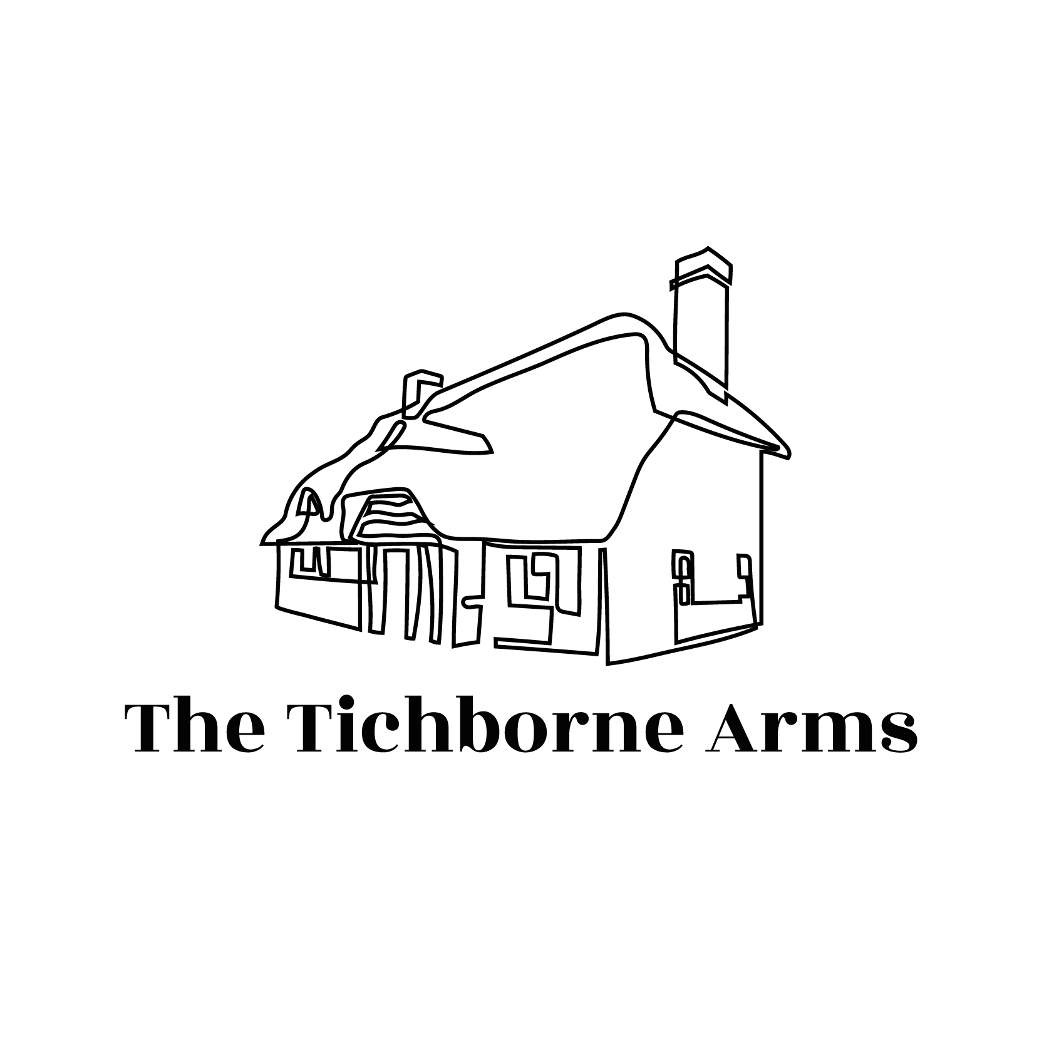

**Something to Drink**

***A Classic Bloody Mary 10***

***Raimes Fizz Elderflower, Peach or Blackcurrant Liqueur 15***

***Frozen Margaritas Glass 10*** ***Choose from a Salty or Spicy Rim***

***A Magnum of Love By Leoube Rose (1.5L) 100***

***Glass of Pimms & Lemonade 10 Jugs of Pimms & Lemonade 28***

***Classic Pina Colada w Koku Kanu 12***

**STARTERS**

Marinated Belazu Olives, Lemon & Rosemary Oil 6.5 (Df)

House Focaccia, Basil Oil 8.5 (V,Vga)

Soup of the Day, House Focaccia 8.5 (V)(Gfa)  
Confit Garlic Hummus, Pickles, Flatbread 7.5 Add Feta 2.5 (Vga,Gfa)

Jalapeno & Mozzarella Croquettes, Confit Garlic Mayo 10

Buffalo Chicken Wings, House Blue Cheese Dip 9 (Gf)

Roast Beetroot, Tenderstem Broccoli, Creamy Blue Ch neese & Watercress Salad, Pickled Walnut Vinaigrette Dressing 11

Burrata, Shaved Courgette, Asparagus, Mint & Broad Bean Salad 12 (GF)

**ROASTS**

Smoked & Red Wine Braised Beef Short Rib, Bone in 28 (Gfa) *(Soft, fall off the bone)*  
34 Day Aged Grass Fed Striploin of Beef 26.5 (Gfa) *(Lots of flavour, more textured than the Shortrib)*

Herb Roast Loin of Hampshire Pork, on the Bone 24 (Gfa)

Butter & Garden Herb Roast Free Range Chicken, 23.5 (Gfa)

Butternut Squash & Onion Veg Wellington 19 (V)

*All Served with Yorkshire Pudding, Roast Potatoes, Summer Peas, Braised Carrots, Roasted Onions, Broccoli & Hispi, Summer Squash Puree, Gravy*

Add Cauliflower Cheese & Bacon 7 ( 2 can share ) (Va)

**CLASSICS**

Double Cheeseburger, Roasted Garlic Mayo, Chilli Jam, Pickles & Fries 18.5 (Gfa)

Battered Line Caught Haddock, Chunky Chips, Tartare Sauce, Minted Peas 16 / 20 (Gf)

‘Moving Mountains’ Beetroot Burger, Smoked‘Cheese’, Garlic Mayo, Chilli Jam,Fries 18.5(Vg)

Skate Wing, Brown Caper Butter, Watercress, 22

**On the Side**

Skin On Fries 5

Chunky Chips 5

Buttered Seasonal Mixed Greens 6

Red Wine Jus 2.5 (Gf)

[pub@tichbornearms.com](mailto:pub@tichbornearms.com) | 01962 588346 | @tichbornearms

Please discuss allergies with your server. **vg= vegan v= vegetarian gf= gluten free df= dairy free a= option available**.

We add a suggested 12.5% service charge to your bill, which is distributed directly to the team. If the service wasn’t up to scratch, don’t pay for it, but please let us know what we could do better. The Tichborne Arms is a cashless pub, only card payments are accepted



Desserts

Blood Orange Sorbet, Cointreau 5

Lemon Posset, Berry Compote, Toasted Almonds 8 (Gf,V)

Sticky Toffee Pudding, Toffee Sauce & Vanilla Ice Cream 8.5 (V)

Strawberry Meringue, Cream & Pistachios 9 (gf,V)

Homemade Brownie, White Chocolate Brownie Ice Cream, Cherry Sauce 8.5 (Gf)

Ice Creams & Sorbets 2.5 per scoop

*Vanilla, Strawberry, Chocolate, Salted Caramel*

*White Chocolate & Brownie  
Vegan Vanilla, Vegan Salted Caramel,  
Mango Sorbet, Blackcurrent Sorbet*

## Something Smaller

Your choice of coffee from the list below, with your choice of :

French Macarons or a small slice of our Brownie 7.4

## 

## Hot Drinks

River Coffee Flow Blend Coffee 3.7 (*double shot)*

*Espresso, Americano, Macchiato, Cappuccino, Flat White, Latte, Mocha + Oat Milk or Soya*

*+ a shot of syrup Vanilla / Hazelnut / Caramel 0.5*

Mug of Tea 3

*Breakfast Tea, Foraged Fruits, Earl Grey, Chamomile,*

*Lemon & Ginger, Green Tea, Peppermint*

Single Origin Hot Chocolate 3.5

*+ mini marshmallows and whipped cream 0.5*

## 

## After Dinner Drinks

Espresso Martini 10

Vodka, Kahlua, Espresso

Dessert Wine

2020 Sauternes Les Garonelles, Lucien Lurton 75ml 10

Liquer Coffees 8

Jamesons, Tia Maria, Courvoisier, Baileys, Drambuie or Amaretto

[pub@tichbornearms.com](mailto:pub@tichbornearms.com) | 01962 588346 | @tichbornearms

Please discuss allergies with your server. **vg= vegan v= vegetarian gf= gluten free df= dairy free a= option available.**

We add a suggested 12.5% service charge to your bill, which is distributed directly to the team. If the service wasn’t up to scratch, don’t pay for it, but please let us know what we could do better. The Tichborne Arms is a cashless pub, only card payments are accepted.